**VersionLearn**

**Executive Summary**

VersionLearn is an innovative collaborative learning platform designed to empower students from grades 6 to 12 with an engaging, interactive, and academic-focused experience. The app addresses the growing demand for personalised learning tools and peer collaboration in the rapidly evolving EdTech industry, which is projected to reach $400 billion globally by 2027.

The platform bridges a significant market gap by combining subject-specific hubs and peer-driven mentoring, which are often missing in existing solutions like Toppr, Byju’s, and Doubtnut. These features make VersionLearn a unique and effective solution for students who struggle to find reliable study resources, collaborate with peers, or track their academic progress.

Key features include:

* **Subject-Specific Hubs:** Dedicated spaces for each subject where students can ask questions, share resources, and collaborate.
* **Progress Tracking:** Tools for students to monitor their improvement in individual subjects.

By focusing on user-friendly design and addressing core pain points such as resource accessibility, lack of collaboration, and absence of progress tracking, VersionLearn is well-positioned to revolutionise the way students learn and interact academically. This report delves deeper into the market potential, competition analysis, and product roadmap to demonstrate how VersionLearn fulfils its promise to be an all-in-one learning companion.

### 

### **Gap Analysis**

#### **Market Gap**

The current EdTech market lacks an engaging and collaborative platform focusing on peer-driven academic support for grades 6-12 students. Existing solutions often fail to provide personalised progress tracking and interactive features that foster student collaboration and motivation.

### **Product Description**

#### **Product Overview**

**VersionLearn** is an innovative EdTech platform designed to fill the gap in collaborative learning for students. It combines subject-specific hubs and real-time progress tracking to make learning engaging and effective. The platform operates on AI-driven insights, interactive challenges, and community-driven solutions.

### **Comparison of Alternative Products**

| **Product Name** | **Key Features** | **Pricing** | **Strengths** | **Weaknesses** |
| --- | --- | --- | --- | --- |
| Byju’s | Video lessons, interactive quizzes, live classes |  | Strong brand, high-quality content | Expensive, lacks gamification |
| Toppr | Doubt-solving, adaptive practice, live classes |  | Affordable, personalised learning | Limited gamified features |
| DoubtNut | Instant doubt-solving via video explanations |  | Free/low-cost, focuses on doubt clearance | Limited subject coverage, lacks collaboration |

### 

### 

### **Uniqueness of Your Product**

* Unlike competitors, **VersionLearn** combines subject-specific hubs, gamification, and real-time progress tracking.
* It addresses engagement and collaboration through AI-driven peer learning.
* Provides superior customisation options for students to track and improve their academic growth.

**Design and Engineering Standards**

### **1. App Design Architecture**

**Frontend (UI/UX):**

* **Home Screen:** Display the user’s learning progress, trending courses, or technology updates.
* **Version Tracker:** A dashboard showing the version history of technologies, with a comparison chart for features and changes.
* **Learning Path Screen:** Display available learning paths, where users can track their progress in each.
* **Community Section:** A forum or messaging system where users can interact and discuss.
* **Profile Page:** Users can manage their personal information, preferences, and see their learning progress.

**Backend (Architecture):**

* **Database:** Use Firebase Firestore as a cloud-hosted NoSQL database to store user profiles, learning content, version histories, quiz data, and progress tracking in real time.
* **APIs:** Develop RESTful APIs using Node.js to handle key operations such as user registration, login, progress updates, content management, and community interactions.
* **User Authentication:** Utilise Firebase Authentication for secure and scalable login methods, including email/password and OAuth-based sign-ins.
* **Data Sync:** Leverage Firebase’s real-time syncing capability to ensure users can seamlessly access their learning material across multiple devices.
* **Version Control for Learning Paths:** Implement a backend mechanism within Firestore to maintain and manage different versions of tutorials and learning modules, allowing users to follow updated or older versions as needed.
* **Server Hosting:** Deploy backend services on Google Cloud for reliable, scalable server-side execution with minimal latency.

### **2. UI/UX Design Principles**

* **Simplicity:** Keep the user interface clean, with a minimalistic approach to avoid overwhelming users.
* **User-Centred:** Design with the user in mind, ensuring easy navigation and quick access to features like learning paths or tutorials.
* **Responsive Design:** Ensure the app works smoothly across different devices (phones, tablets, desktops).
* **Consistent Visual Theme:** Use a consistent colour scheme, fonts, and button styles to create a unified look throughout the app.

### **3. Wireframes/Layouts (Example)**

1. **Home Screen:**
   * Top navigation bar with app logo and user profile icon.
   * The main content section shows a welcome message and progress tracker.
   * Quick links to trending tutorials, quizzes, and community discussions.
2. **Version Tracker Screen:**
   * Timeline or list of versions of the technology/software.
   * A comparison slider or table showing differences between versions.
   * A search bar to filter technologies.
3. **Learning Path Screen:**
   * A vertical list of stages or modules, each containing a tutorial.
   * Progress bars for each module show how far the user has progressed.
4. **Community Section:**
   * A forum with topic categories.
   * Ability for users to create new threads and reply to discussions.

### **4. Technology Stack**

* **Frontend:** Built using React Native to ensure a seamless cross-platform experience across both Android and ios devices, offering native performance and smooth UI rendering.
* **Backend:** Developed with Node.js and Express.js to create robust, scalable REST APIs for handling user interactions, learning progress, and content delivery.
* **Database:** Integrated with Firebase Firestore, a NoSQL cloud database that offers real-time syncing, offline support, and seamless integration with Firebase services.
* **Authentication:** Utilises Firebase Authentication for secure user login, sign-up, and session management, with support for email/password and OAuth providers.
* **Version Control & Collaboration:** All development is managed using Git and GitHub, enabling version tracking, team collaboration, and streamlined code management.

### **5. User Flow**

* **New User Flow:**
  1. The user downloads the app and signs up.
  2. The user is introduced to the app with a tutorial.
  3. The user starts by selecting a learning path.
  4. The user progresses through tutorials and takes quizzes.
  5. User tracks progress and can interact with the community.
* **Existing User Flow:**
  1. User logs in.
  2. User views their progress and resume learning.
  3. The user interacts with the community and takes quizzes.

### **6. Monetisation Strategy**

* **Freemium Model:** Offer basic content for free with advanced content behind a subscription paywall.
* **In-App Purchases:** Users can buy individual tutorials or learning paths.
* **Ads:** Display ads in the free version to generate revenue.

### **7. Security Considerations**

* **Data Encryption:** Encrypt sensitive user data like passwords and learning progress.
* **Role-Based Access:** Different levels of access for users, mentors, and admins.
* **Two-Factor Authentication:** Provide an extra layer of security during login.

**ENGINEERING STANDARDS**

### **1. ISO (International Organization for Standardization)**

* **ISO 9001: Quality Management Systems**
  + **Relevance:** Ensures that your app follows a structured approach to maintaining quality, meeting user requirements, and continuously improving the app’s performance.
* **ISO 27001: Information Security Management**
  + **Relevance:** Critical for protecting user data (personal details, learning progress, etc.) and ensuring that any online interactions or data exchanges are secure.
* **ISO 31000: Risk Management**
  + **Relevance:** Helps in managing risks related to data security, system performance, or any external factors affecting the app’s availability and usability.

### **2. IEEE (Institute of Electrical and Electronics Engineers)**

* **IEEE 12207: Software Life Cycle Processes**
  + **Relevance:** Guides the complete software development lifecycle for your app, from planning to design, testing, and maintenance.
* **IEEE 754: Floating-Point Arithmetic**
  + **Relevance:** If the app involves any data processing with floating-point numbers (e.g., statistical analysis of version control data, user performance metrics), this standard ensures accurate and consistent calculations.

### **3. IETF (Internet Engineering Task Force)**

* **RFC 791: Internet Protocol (IP)**
  + **Relevance:** Necessary for ensuring that your app follows standardized protocols when it communicates over the internet, especially when interacting with cloud servers or external services.
* **RFC 5246: Transport Layer Security (TLS 1.2)**
  + **Relevance:** Ensures that your app’s communication over the internet is secure, which is crucial for maintaining user privacy and data integrity, especially for login sessions and data transactions.

### **4. BSI (British Standards Institution)**

* **BS ISO 45001: Occupational Health and Safety Management Systems**
  + **Relevance:** While this standard is primarily focused on physical safety in work environments, if the app integrates with devices or used in educational institutions, ensuring health and safety standards will be important.

### **5. UL (Underwriters Laboratories)**

* **UL 94: Standards for Flammability of Plastic Materials**
  + **Relevance:** If your app involves hardware integration (for instance, educational devices), you would need to ensure that any hardware meets UL standards for safety.

### **6. General Software Development Standards**

* **Accessibility Standards (WCAG 2.0/2.1)**
  + **Relevance:** Since VersionLearn will likely cater to a wide range of users, including those with disabilities, adhering to web accessibility standards will ensure your app is usable by all.
* **GDPR (General Data Protection Regulation)**
  + **Relevance:** If your app collects user data (personal info, progress reports, etc.), it’s important to comply with GDPR standards to protect user privacy, especially if the app operates in regions like the EU.

### **Additional Standards**

1. **ISO 25010: Software Product Quality Model**
   * **Relevance:** This standard focuses on software quality characteristics, such as functionality, usability, efficiency, security, and maintainability, which are crucial for the success of any application, especially an educational tool.
2. **ISO/IEC 27018: Protection of Personal Data in the Cloud**
   * **Relevance:** If you plan to store user data (e.g., progress, feedback) in the cloud, this standard outlines guidelines for data protection, helping you ensure that user data is handled securely.
3. **IEEE 829: Software Test Documentation**
   * **Relevance:** Guides the creation of test documentation during the development process, which helps you ensure that the app functions correctly, is free from bugs, and meets performance expectations.
4. **ISO/IEC 9126: Software Engineering — Product Quality**
   * **Relevance:** Focuses on the quality attributes of software products like functionality, reliability, usability, and efficiency—key to building a successful and effective educational app.
5. **IEEE 1012: Standard for Software Verification and Validation**
   * **Relevance:** Ensures that the app is developed according to specifications and functions correctly. For an app like VersionLearn, it ensures that features like version tracking, quiz results, and learning content display work as expected.
6. **CMMI (Capability Maturity Model Integration)**
   * **Relevance:** CMMI helps improve your app development process by defining key practices that focus on the maturity of processes, which can be applied as VersionLearn scales.
7. **Privacy Shield Framework (EU-U.S. & Swiss-U.S.)**
   * **Relevance:** If your app collects user data from the EU or the U.S., the Privacy Shield helps ensure compliance with international data privacy laws. This is critical for maintaining user trust and legal compliance.
8. **NIST (National Institute of Standards and Technology) Cybersecurity Framework**
   * **Relevance:** A comprehensive framework for ensuring that your app adheres to top cybersecurity practices, especially when dealing with sensitive data like user information or educational progress.

**2D Design:**

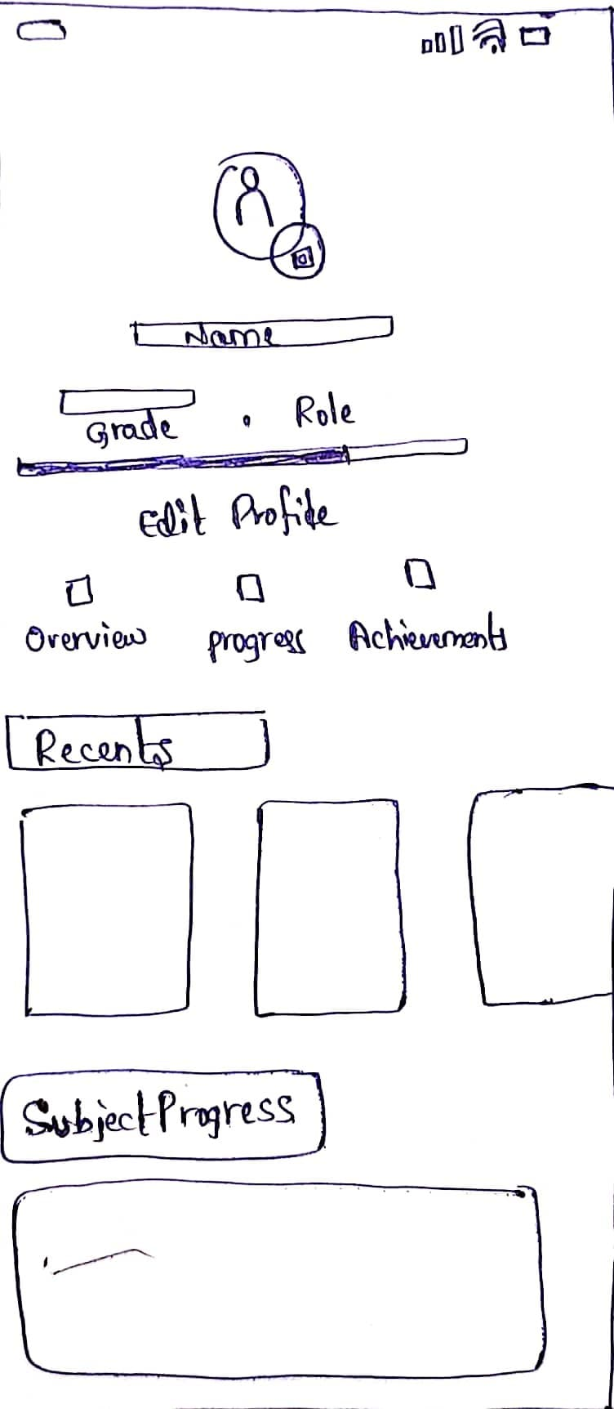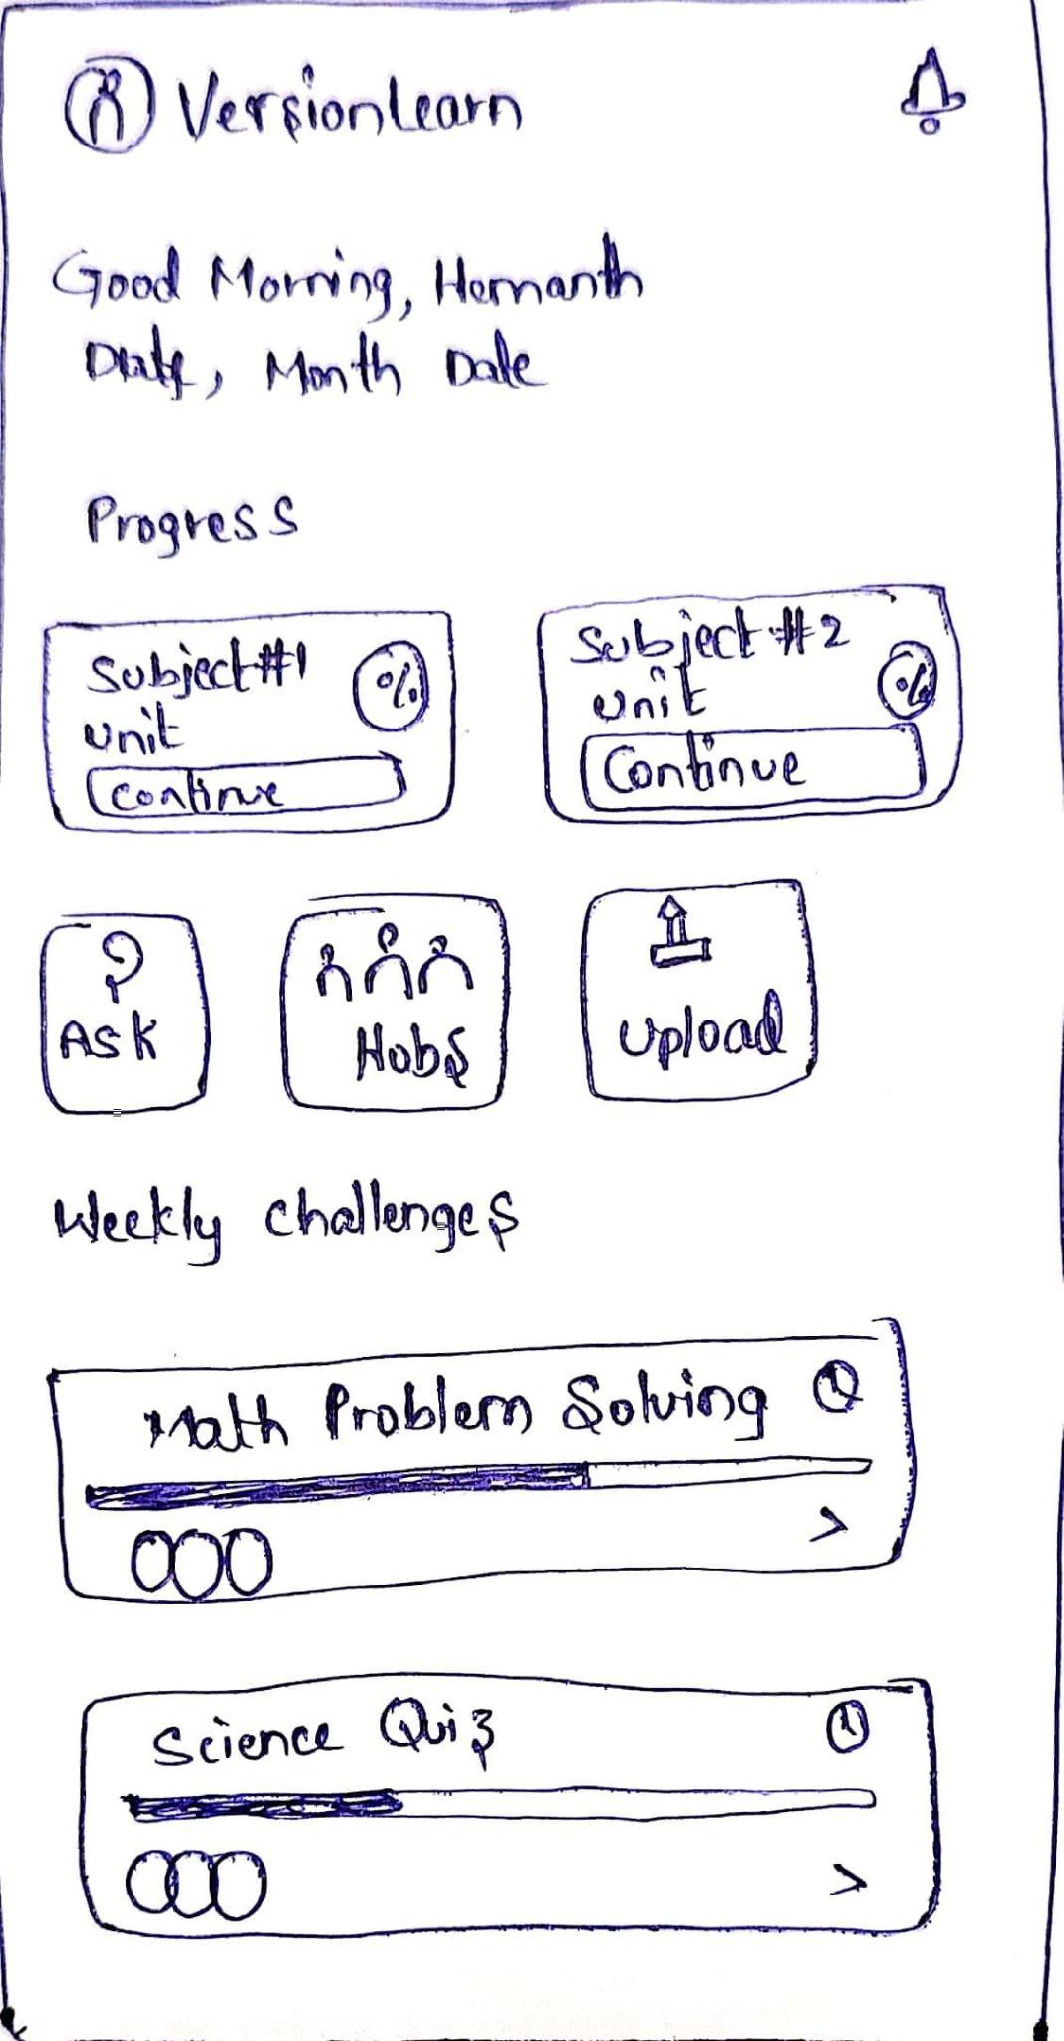

**3D Design:**

**3D Model of the Product:**

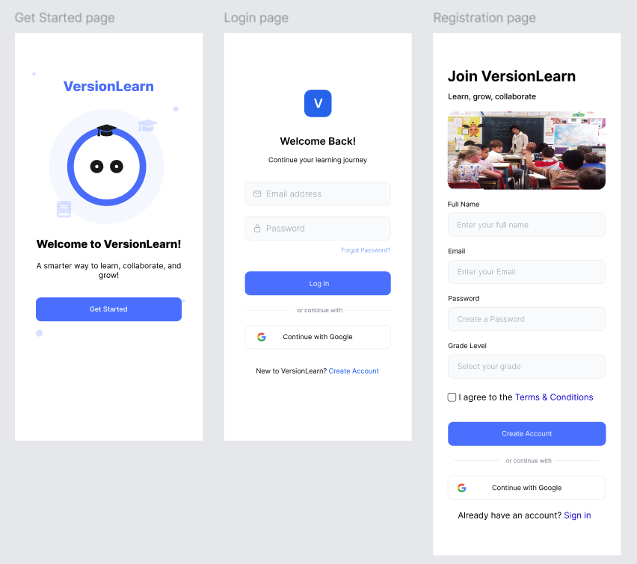

**Functional Prototype:**

**Prototype Description:**

The functional prototype of our e-learning mobile application, VersionLearn, was developed as a digital/virtual prototype using software development tools. The frontend was built using React Native for a cross-platform experience, while the backend was developed using Node.js and hosted on Google Cloud. The real-time database and authentication features were implemented using Firebase Firestore and Firebase Authentication, respectively. We followed an agile development process, beginning with wireframes and UI designs in Figma, then progressively developed core functionalities like user registration, video learning interface, note uploading, Q&A forums, and profile management.

**Testing and Validation:**

**Multiple rounds of testing were conducted, including:**

* **Functional Testing:** Ensured every button, form, and screen interaction performed as expected.
* **User Testing:** Shared the prototype with a small group of target users (students) to gather feedback.
* **Bug Fixing:** Based on feedback, we refined navigation flow, optimized UI responsiveness, and improved the saved notes and video playback modules.
* **Database Testing:** Firebase’s real-time sync was validated by logging in across multiple devices and confirming data consistency.

These tests confirmed that core learning features such as video content access, saved material viewing, and community questions worked effectively under normal usage.

**Conclusion and Future Work:**

**Summary of Key Points:**Our prototype successfully demonstrated the need for a centralized, user-friendly e-learning platform tailored for students. Gap analysis showed a lack of simplified platforms combining notes, video learning, and community Q&A. The uniqueness of our product lies in its intuitive design, fast content access, and organized structure without unnecessary gamification or distractions.  
**Challenges Faced:**We faced challenges integrating Firebase with Node.js for secure authentication and in managing complex UI flows in React Native. These were overcome by modularising code and continuous testing.

**Future Improvements:**We plan to add advanced search filters, dark mode, offline note access, and potential integration with third-party live class providers for extended features.